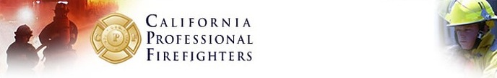


SAVE THE DATE

CPF Winter District Meetings

Get the Latest on 2014 Statewide Elections, CPF's 75th Anniversary Convention and Other Important Issues Affecting Our Members
Be sure to mark your calendars to attend CPF District Meeting's coming up in February 2014.
Details will follow in early January of 2014.
1st District - San Diego
DATE: Monday, February 24th
2nd District - Burbank
DATE: Tuesday, February 25th
3rd District - Stockton
DATE: Tuesday, February 11th
4th District - Concord
DATE: Monday, February 10th
****CPF leadership from Districts 5 (Federal Firefighters), 6 (CDF Firefighters, Local 2881), 7 (LA County Firefighters, Local 1014) and 8 (LA City Firefighters, Local 112) may attend any District Meeting in your area!
California Professional Firefighters, 1780 Creekside Oaks, Sacramento, CA 95833

